Customer Shopping Behavior Insights

Project Overview
This project analyzes customer shopping behavior using transactional data from 3,900 purchases across various product categories. The goal is to uncover insights into spending patterns, customer segments, product preferences, and subscription behavior to guide strategic business decisions.

Dataset Summary
- Rows: 3,900
  - Columns: 18
  - Key Features:
    - Customer demographics (Age, Gender, Location, Subscription Status)
    - Purchase details (Item Purchased, Category, Purchase Amount, Season, Size, Color)
    - Shopping behavior (Discount Applied, Promo Code Used, Previous Purchases, Frequency of Purchases, Review Rating, Shipping Type)
  - Missing Data: 37 values in Review Rating column

Exploratory Data Analysis using Python
We began with data preparation and cleaning in Python:

- Data Loading: Imported the dataset using pandas.

- Initial Exploration: Used df.info() to check structure and .describe() for summary statistics.
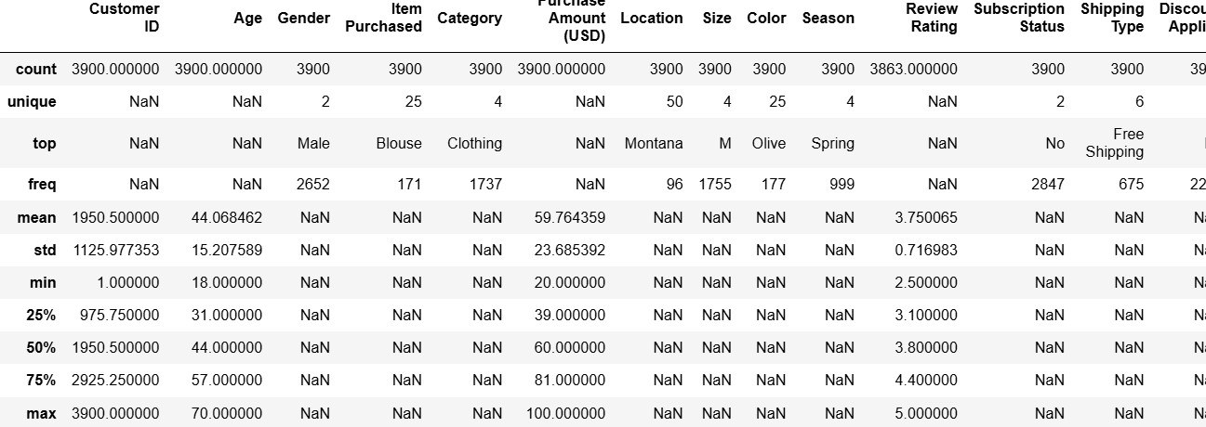

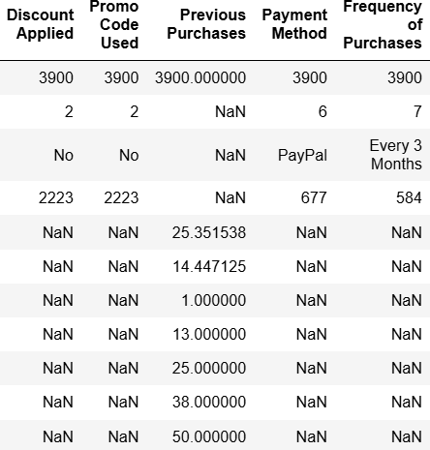

- Missing Data Handling: Checked for null values and imputed missing values in the
Review Rating column using the median rating of each product category.

- Column Standardization: Renamed columns to snake case for better readability and documentation.

- Feature Engineering:

  - Created age_group column by binning customer ages.

  - Created purchase_frequency_days column from purchase data.

- Data Consistency Check: Verified if discount_applied and promo_code_used
were redundant; dropped promo_code_used.

- Database Integration: Connected Python script to PostgreSQL and loaded the cleaned DataFrame into the database for SQL analysis.

Data Analysis using SQL (Business Transactions)
We performed structured analysis in PostgreSQL to answer key business questions:

- Revenue by Gender – Compared total revenue generated by male vs. female customers.

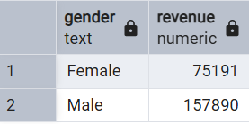

- High-Spending Discount Users – Identified customers who used discounts but still spent above the average purchase amount.
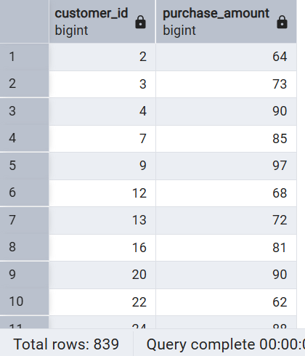

- Top 5 Products by Rating – Found products with the highest average review ratings.

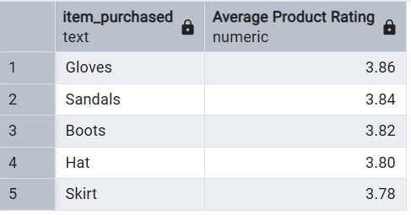

- Shipping Type Comparison – Compared average purchase amounts between Standard and Express shipping.
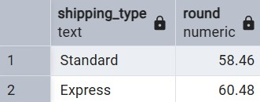

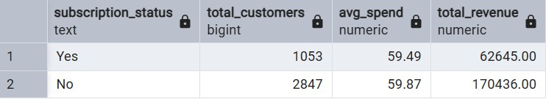
- Subscribers vs. Non-Subscribers – Compared average spend and total revenue across subscription status.

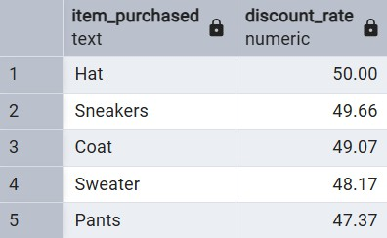
- Discount-Dependent Products – Identified 5 products with the highest percentage of discounted purchases.

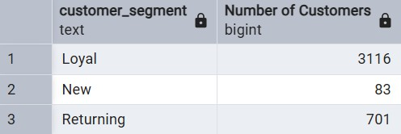
- Customer Segmentation – Classified customers into New, Returning, and Loyal segments based on purchase history.

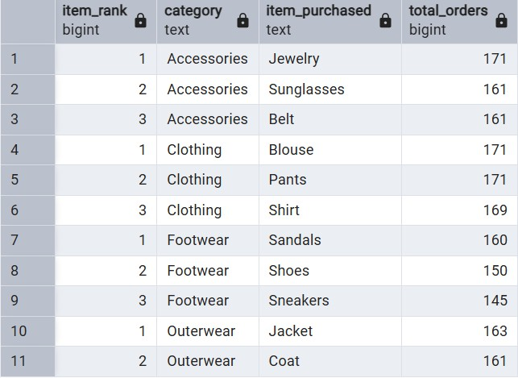
- Top 3 Products per Category – Listed the most purchased products within each category.
- Repeat Buyers & Subscriptions – Checked whether customers with >5 purchases are more likely to subscribe.
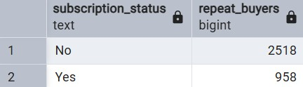
- Revenue by Age Group – Calculated total revenue contribution of each age group.

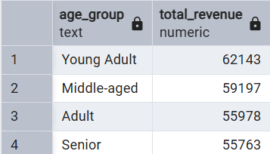

A) Dashboard in Power BI

Finally, we built an interactive dashboard in Power BI to present insights visually.

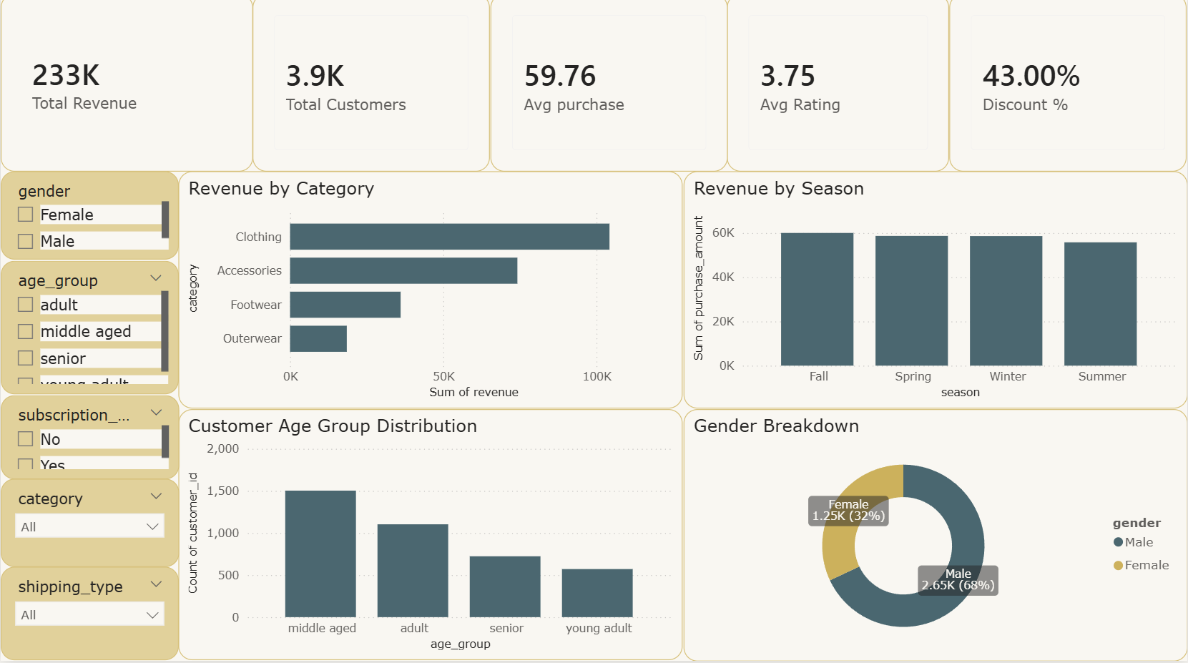

A 3-page interactive Power BI dashboard was created to visualize all findings.

Page 1 – Customer Overview

- Total Revenue
- Average Purchase Amount
- Average Rating
- Discount Usage %
- Revenue by Category
- Revenue by Season
- Age Group and Gender Distribution
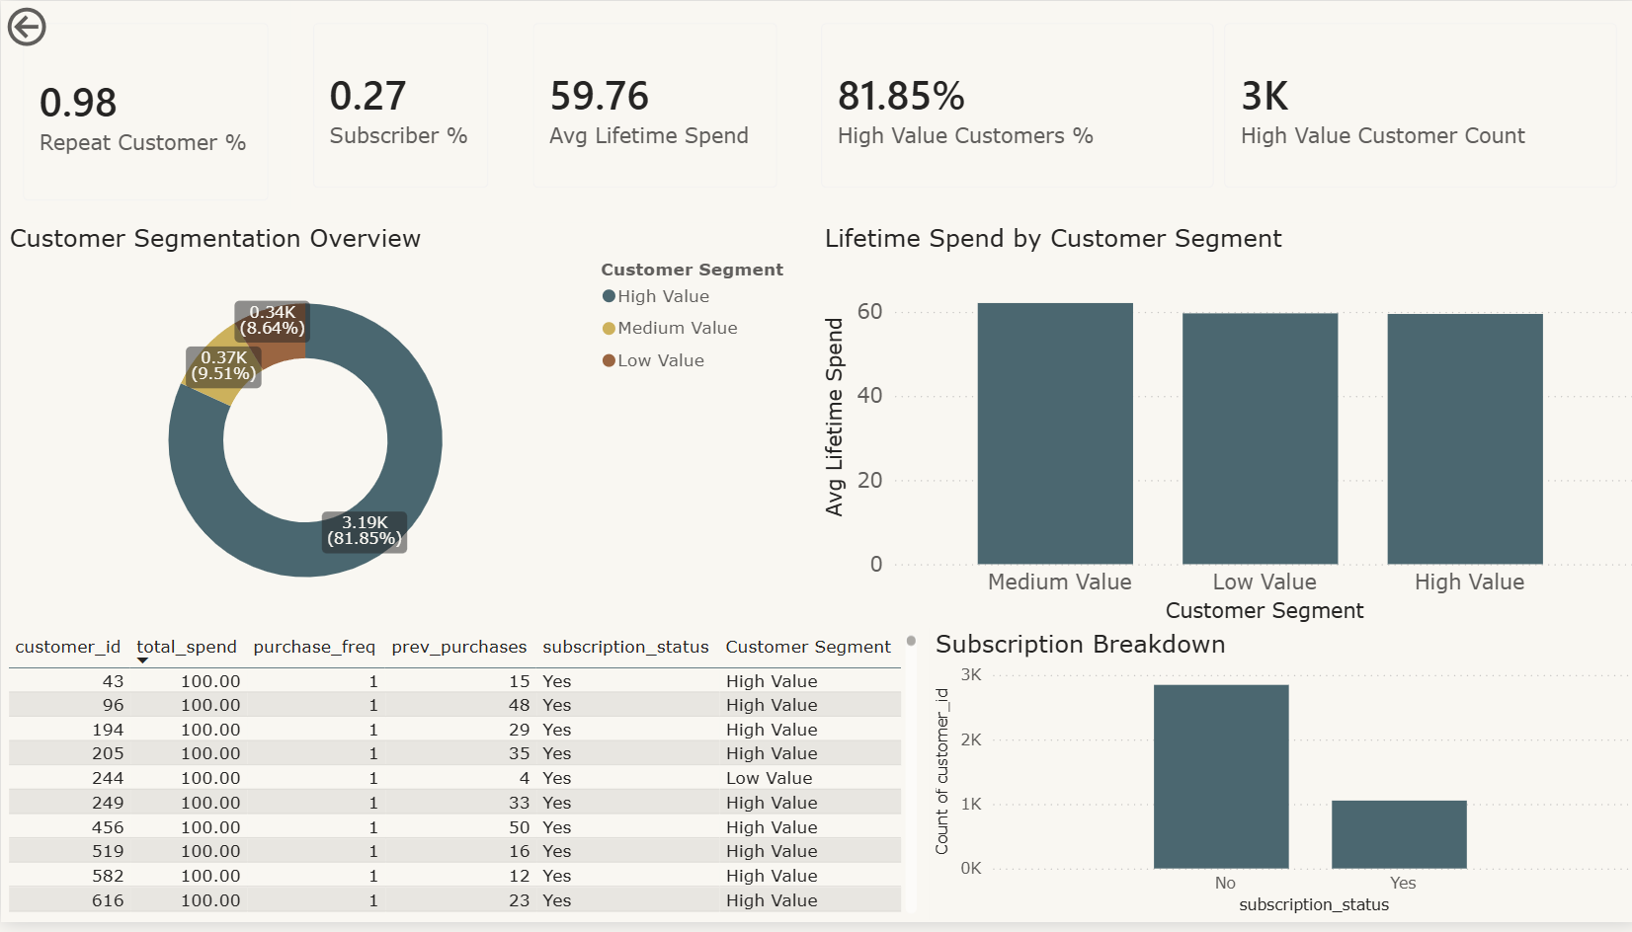

Page 2 – Customer Value & Segmentation

- Repeat Customer %
- Subscriber %
- Average Lifetime Spend
- Customer Segments (High, Medium, Low Value)
- Subscription Breakdown
- Top Customer Table
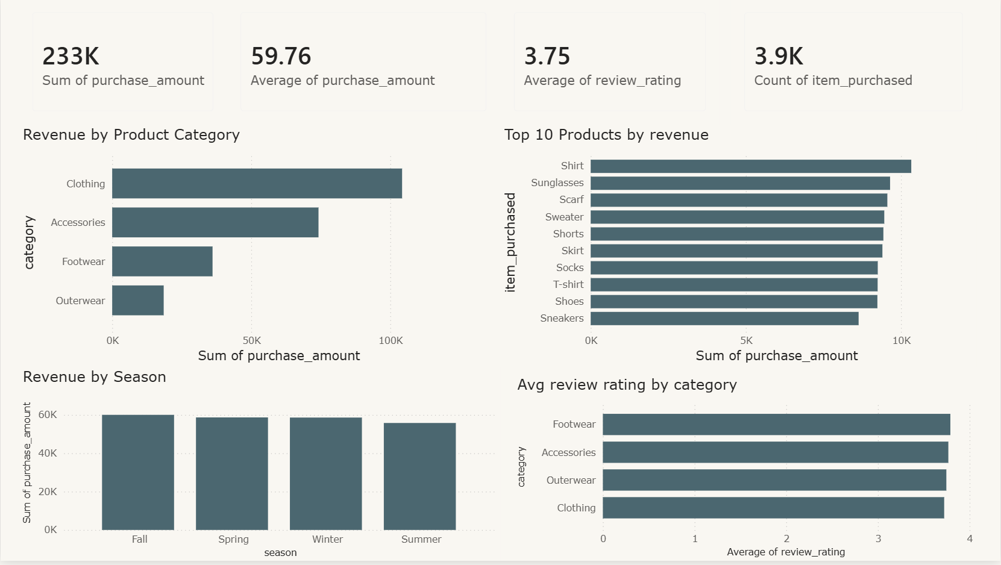

Page 3 – Product Insights

- Revenue by Product Category
- Top 10 Products by Revenue
- Seasonal Revenue Trends
- Average Rating by Category

B) Key Performance Indicators (KPIs)
- Total Revenue
- Total Customers
- Repeat Customer %
- Subscriber %
- Average Purchase Amount
- Average Lifetime Spend
- Average Rating
- Units Sold

Business Recommendations

1. Boost Subscription Adoption
- Subscribers exhibit higher spend and loyalty
- Offer exclusive perks: free shipping, early deals, rewards

2. Strengthen Loyalty Programs
- Loyal customers drive majority of revenue
- Introduce point-based rewards, birthday coupons, renewal bonuses

3. Optimize Discount Strategy
- Some products are overly discount dependent
- Adjust pricing to protect margins while retaining conversion

4. Promote High-Rated, High-Revenue Products
- Use these in marketing creatives
- Recommend them during checkout
- Bundle with accessories

5. Focus on High-Value Age Groups
- Middle-aged adults drive highest revenue
- Tailor personalized promotions

6. Improve Express Shipping Offers:
- Express-shipping customers spend more
- Incentivize express upgrades during key seasons

- Conclusion:

This project demonstrates a complete analytics pipeline:
- Python for cleaning & feature engineering
- SQL for deep business analysis
- Power BI for interactive dashboards
- DAX for KPI modeling
The findings provide actionable intelligence that can improve customer acquisition, retention, marketing strategy, product positioning, and revenue management.

